FINAL PROJECT REPORT
Project Title:
Global Food Production Trends and Analysis: A Comprehensive Study from 1961 to 2023 Using Power BI
Skill wallet ID:SWUID20250181666
Date: 08-October-2025


Content
- Introduction
  - Project overviews
  - Objectives
- Project Initialization and Planning Phase
  - Define Problem Statement
  - Project Proposal (Proposed Solution)
  - Initial Project Planning
- Data Collection and Preprocessing Phase
  - Data Collection Plan and Raw Data Sources Identified
  - Data Quality Report
  - Data Exploration and Preprocessing
- Data Visualization
  - Framing Business Questions
  - Developing Visualizations
- Dashboard
  - Dashboard Design File
- Report
  - Story Design File
- Performance Testing
  - Utilization of Data filters
  - No of Calculation Field
  - No of Visualization
- Conclusion/Observation
- Future Scope
- Appendix
  - GitHub & Project Demo Link

1. Introduction
  - Project overviews:

This final project report provides a thorough examination of world food production patterns from 1961 to 2023. Using Power BI for dynamic data visualization, Important agricultural products including rice, wheat, maize, tea, and coffee are included in the research, along with in-demand fruits like oranges, apples, bananas, and grapes. The research provides insightful information on how global agriculture has changed over the past years by displaying production numbers and trends across various areas and historical periods.

Major findings include The production of wheat reached 282 billion tonnes, rice reached 269 billion tonnes, while maize yielded a notable increase since the late 1980s. Regional contributions to the world's fruit supply and top producers of green coffee are also highlighted in the report. Deeper comprehension of global food production patterns is made possible by the use of a variety of Power BI charts, including as bar, area, gauge, and donut charts, which provide an interactive and transparent perspective of the data.

  - Objectives:

This project's primary objective is to analyze historical data on global food production from 1961 to 2023 with the following goals in mind:

- To see the patterns in the production of important crops including green coffee, tea, wheat, rice, and maize.
- To determine which nations and regions produce the most important agricultural goods worldwide.
- To evaluate the overall production amounts of common fruits, such as oranges, avocados, bananas, apples, and grapes.
- To comprehend the evolution of agricultural production and examine growth trends throughout time.
- To offer data-driven insights that can guide strategic choices in the food production and agriculture sectors.
2. Project Initialization and Planning Phase

2.1 Define Problem Statement:
As a global agriculture policy analyst, your primary objective is to identify regions with low staple crop production in order to guide strategic resource allocation. However, the challenge lies in navigating vast and fragmented historical datasets that span multiple commodities and geographies. This complexity can be overwhelming, making it difficult to extract actionable insights. To make informed policy decisions, you require a unified, visual summary that consolidates key trends and highlights production gaps across regions. Such a summary would not only simplify the data landscape but also empower you to prioritize interventions with clarity and confidence.
2.2 Project Proposal (Proposed Solution)
This project proposes a comprehensive Power BI dashboard to simplify the analysis of global food production trends from 1961 to 2023. It tackles the challenge of fragmented agricultural data by consolidating key commodities
like rice, wheat, maize, and fruits into an interactive, visual format. The dashboard enables stakeholders to filter by crop, region, and year, compare outputs, and extract actionable insights for strategic planning. By leveraging data cleaning, modeling, and visualization techniques, the solution empowers better resource allocation, policy formulation, and supply chain decisions across the global food ecosystem.
2.3 Initial Project Planning:
This project aims to develop a comprehensive Power BI dashboard that analyzes global food production trends from 1961 to 2023. The goal is to help stakeholders in agriculture and food policy visualize historical patterns, compare regional outputs, and derive actionable insights for strategic planning. The dashboard will consolidate fragmented data across key commodities—such as rice, wheat, maize, tea, coffee, and various fruits—into an interactive, filterable format. It will include features like region-wise and year-wise comparisons, exportable reports, and performance-optimized visuals. By transforming complex datasets into accessible insights, this solution will support better resource allocation, policy formulation, and supply chain decisions across the global food ecosystem.
3. Data Collection and Preprocessing Phase
3.1 Data Collection Plan and Raw Data Sources Identified
To support strategic decision-making in agriculture and food policy, this data collection plan lays the foundation for a robust Power BI dashboard analyzing global food production trends from 1961 to 2023. It begins with a clear project overview focused on visualizing historical patterns and identifying regional strengths. The data will be sourced from publicly available, credible platforms such as FAOSTAT and Kaggle, which offer extensive coverage of agricultural production across countries and commodities. These raw datasets—selected for their reliability and relevance—include production volumes segmented by crop, region, and year. By ensuring meticulous data curation and integrity, the plan enables accurate modeling, insightful visualizations, and meaningful reporting that can guide policy formulation and resource allocation across the global food ecosystem.
3.2 Data Quality Report
The Data Quality Report ensures the reliability of global food production data sourced from Kaggle by identifying key issues such as missing values, duplicates, inconsistent naming, and outliers. Each issue is assessed for severity and paired with a resolution plan using Power BI and Power Query techniques—like filtering nulls, standardizing formats, and applying statistical checks. This structured approach enhances data integrity, enabling accurate analysis and confident decision-making.
3.3 Data Exploration and Preprocessing
This data preparation workflow ensures a reliable foundation for analyzing global food production trends from 1961 to 2023. It begins by sourcing annual crop data across regions, followed by rigorous cleaning—removing missing values, duplicates, and inconsistencies. Using Power Query, the data is transformed for comparative analysis with calculated growth metrics and regional totals. Numeric fields and entity codes are properly typed, while column structures are refined for clarity. Relationships between fact and dimension tables are modeled in Power BI, enabling dynamic reporting through DAX measures.

4. Data Visualization
4.1 Framing Business Questions:
To support strategic decision-making, key business questions were defined to guide the analysis of global food production data. These focused on:
- Trends in staple crop production (rice, wheat, maize) from 1961–2023
- Top-producing countries for crops like coffee, tea, and major fruits
- Growth patterns and shifts in crop output over time
- Regional contributions to global fruit production
- Insights to inform future agricultural strategies and investments
These questions shaped the data exploration and visualization to deliver actionable insights for stakeholders in agriculture and food security.
4.2 Developing Visualizations:
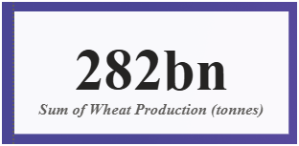
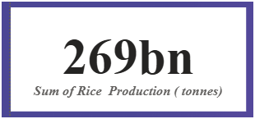
- Scenarios 1 & 2: KPI/cards for total rice (269B tonnes) and wheat (282B tonnes) production.
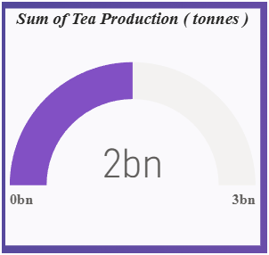
- Scenarios 3 & 4: Gauge chart for tea; clustered bar chart for green coffee by region.
Visualization: Gauge chart
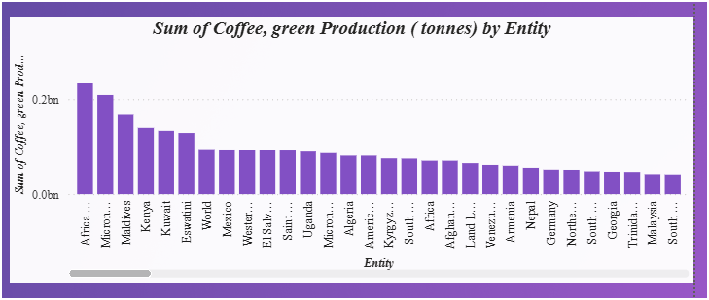
Visualization: Bar Chart

- Scenario 5: Area chart showing yearly trends for wheat, maize, and rice
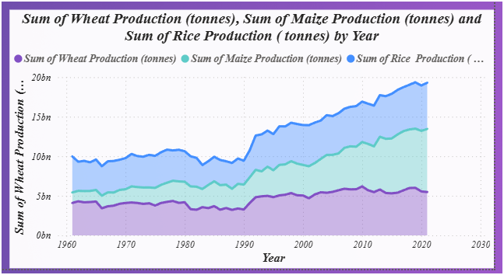

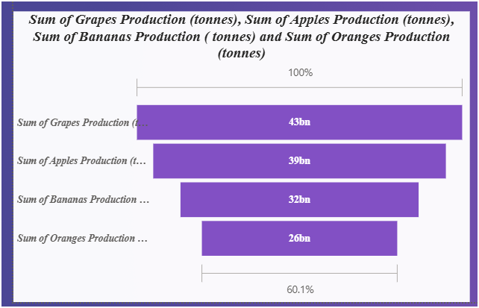
- Scenario 6: Funnel Chart comparing fruit production across regions

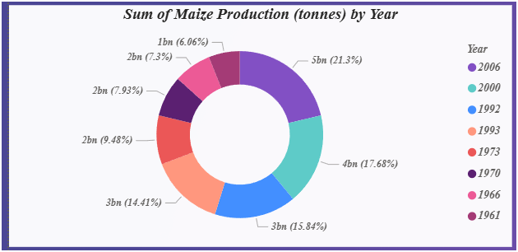
- Scenario 7: Donut chart highlighting maize production spikes by year
- Scenario 8: Area chart comparing total output of grapes, apples, bananas, and oranges
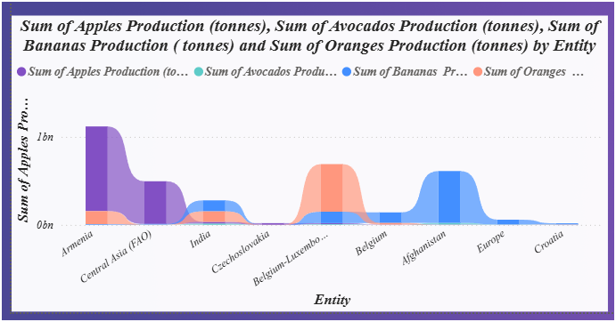

5. Dashboard
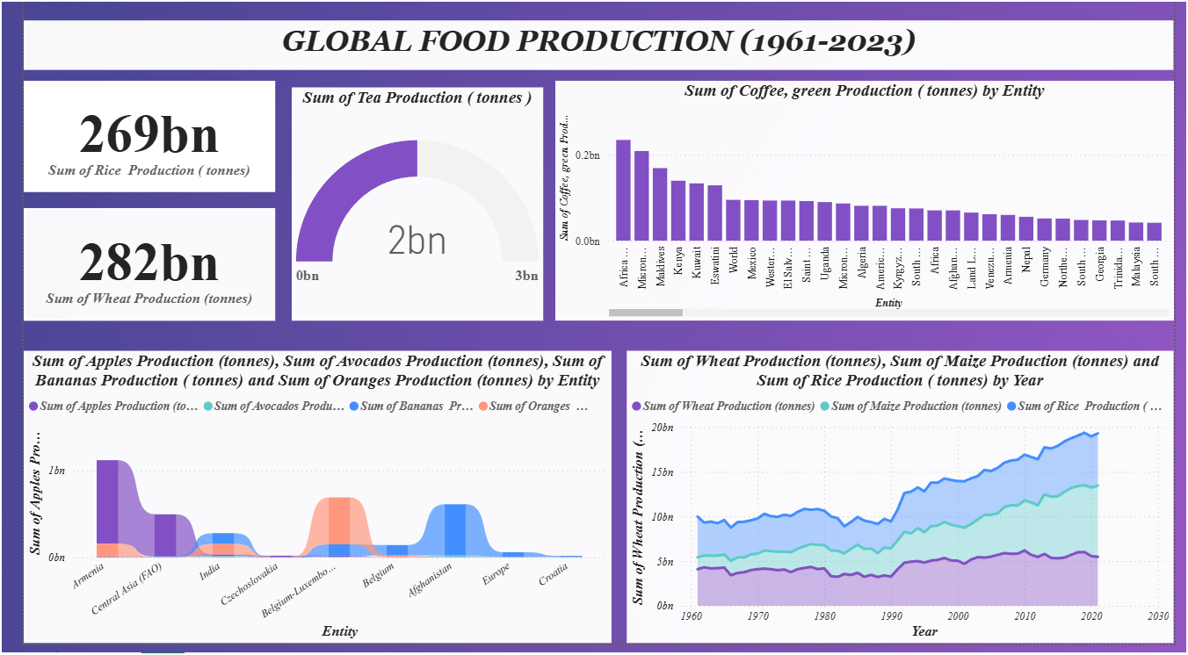
5.1 Dashboard Design File:

6. Report:
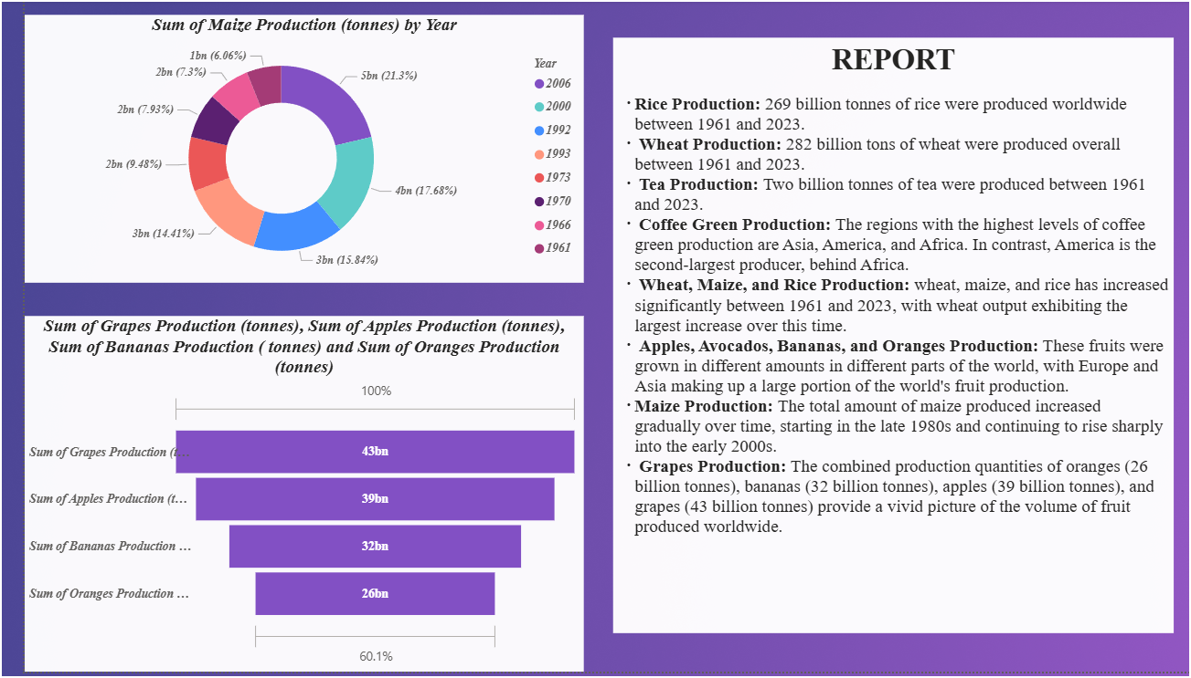
7. Performance Testing
7.1 Utilization of Filters
- Selected “Country” as a Filter
7.2 No of Visualizations/ Graphs

- Sum of Rice Production (tonnes)
- Sum of Wheat Production (tonnes)
- Sum of Tea Production (tonnes)
- Sum of Coffee, Green Production (tonnes) by Entity
- Sum of Wheat Production (tonnes), Maize Production (tonnes), Rice Production (tonnes) by Year
- Sum of Apples, Avocados, Bananas, Oranges Production (tonnes) by Entity
- Sum of Maize Production (tonnes) by Year
- Sum of Grapes, Apples, Bananas, Oranges Production (tonnes)

Conclusion/Observation
- The dashboard presents a comprehensive analysis of global food production trends from 1961 to 2023, illustrating significant growth across key agricultural sectors.
- It effectively showcases the total production of major crops including Rice, Wheat, Maize, Tea, Coffee, and a range of fruits, segmented by region and year. • From the visuals, it is evident that Rice and Wheat lead global crop production, reflecting their central role in food security and consumption. Maize production shows a consistent upward trend, reaching 2.6 billion tonnes by 2023, indicating its growing importance in both human and livestock consumption.
- Tea and Coffee maintain steady but lower production volumes, highlighting their niche cultivation zones and specialized market demand.
- Fruit production—especially Bananas, Apples, Oranges, and Grapes—remains robust across continents, driven by consumer preferences and improved agricultural practices.
- The dashboard delivers actionable insights into regional strengths, crop-specific trends, and long-term agricultural performance, supporting strategic decisions in global food supply management.
Future Scope
- The dashboard can be enhanced by integrating real-time agricultural data through APIs, enabling dynamic monitoring of crop trends and seasonal variations.
- Incorporating predictive analytics and machine learning models will allow forecasting of crop yields, climate impact, and market demand, supporting proactive decision-making.
- Developing region-specific dashboards (e.g., by country or continent) will provide localized insights for policymakers, agribusinesses, and researchers.
- Adding sustainability metrics such as water usage, carbon footprint, and land efficiency will help assess environmental impact and promote responsible farming practices.

Appendix
10.1 GitHub & Project Demo Link:
- GitHub Repo: https://github.com/Psahoo-2004/Power-BI-Internship-Project.git
- Power BI Demo: https://drive.google.com/file/d/1IABEwZxvUEq2EHW1rInhKmRXgaxAar6t/view?usp=sharing

